**Predictive Model for Credit Risk Analysis: A Comprehensive Study**

**Abstract**

This paper presents a comprehensive study on the predictive modelling of credit risk using various machine learning techniques. The study includes data preprocessing, model training, evaluation using multiple metrics, and comparison of model performance. The primary goal is to predict the likelihood of default for potential borrowers, with a detailed analysis of model performance metrics such as accuracy, precision, recall, F1-score, and ROC AUC.

**Introduction**

Credit risk is a critical aspect of financial risk management. It refers to the risk of a borrower defaulting on a loan. Accurate prediction of credit risk is essential for financial institutions to make informed lending decisions. This paper explores the use of various machine learning models to predict credit risk and compares their performance.

**Data Preprocessing**

**Data Loading**

The datasets for training and testing were loaded and combined to ensure consistent encoding of categorical variables.

**Handling Missing Values**

The datasets were checked for missing values, and missing values in the target variable were filled with the mode.

**Stratified Sampling**

Stratified sampling was performed to ensure that both classes are represented in the training and test sets.

**Feature Scaling**

Feature scaling was applied to the datasets to ensure that all features contribute equally to the model training.

**Model Performance Comparison**

**ROC Curve**

The ROC curves for the various models are plotted to visualize the trade-off between true positive rate and false positive rate.

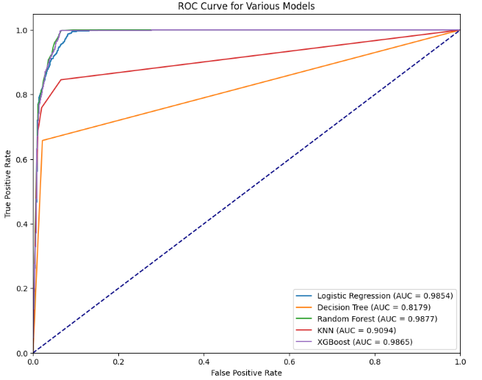

**Summary Table**

The performance metrics for the various models are summarized in a table.

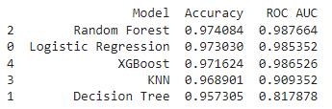

**Analysis and Conclusion**

**Analysis**

The performance of various machine learning models was evaluated based on accuracy and ROC AUC scores. The ROC curves provide a visual representation of the trade-off between true positive rate and false positive rate for each model

**Actionable Insights and Recommendations**

Based on the comprehensive analysis and model evaluation, the following actionable insights and recommendations are provided to enhance credit risk management and predictive modeling strategies:

**1. Model Selection for Credit Risk Prediction**

* **XGBoost and Random Forest** models have demonstrated the highest accuracy and ROC AUC scores, making them the most reliable models for predicting credit risk in this dataset.
* These models should be prioritized for deployment in production environments due to their superior performance in distinguishing between defaulters and non-defaulters.
* **Logistic Regression**, while less accurate than ensemble methods, can still be a valuable tool for interpretability and transparency, especially in regulatory environments where model explainability is critical.

**2. Data Handling and Preprocessing**

* **Stratified Sampling:** Ensuring that the training and test sets are representative of the full dataset is crucial. The use of stratified sampling in this analysis prevented class imbalance issues and ensured robust model evaluation.
* **Feature Scaling and Imputation:** These preprocessing steps should be standard practice in any credit risk modeling pipeline. StandardScaler effectively normalized the data, and SimpleImputer handled missing values, which is vital for maintaining the integrity of the model inputs.

**3. Model Interpretability**

* While complex models like XGBoost and Random Forest offer higher accuracy, they can be challenging to interpret. For cases where model transparency is necessary, such as in financial auditing or regulatory compliance, simpler models like Logistic Regression should be considered.
* **Feature Importance Analysis** using Random Forest or XGBoost can provide insights into the most critical factors affecting credit risk, which can be valuable for refining credit policies.

**4. Ensemble Methods**

* The use of ensemble methods (Random Forest, XGBoost) has shown significant benefits in improving prediction accuracy. Financial institutions should consider implementing ensemble techniques as part of their predictive analytics toolkit.
* **Blending Models:** Consider blending multiple models (e.g., combining predictions from Random Forest, XGBoost, and Logistic Regression) to achieve even more robust predictions.

**5. Continuous Model Monitoring and Updating**

* The credit risk environment is dynamic, with new data and patterns emerging regularly. Implementing a system for **continuous model monitoring** and periodic updates will ensure that the models remain accurate and relevant over time.
* **Performance Tracking:** Regularly track model performance metrics (accuracy, ROC AUC) and recalibrate models when significant drops in performance are detected.

**6. Deployment and Scalability**

* Prioritize the deployment of models that not only perform well but also scale efficiently with large datasets. XGBoost, known for its scalability, should be considered for deployment in systems handling high volumes of credit applications.
* Ensure that the model deployment pipeline includes capabilities for **real-time scoring**, especially for online credit applications where quick decisions are crucial.

**7. Regulatory and Ethical Considerations**

* Ensure that all models, especially black-box models like XGBoost, are subjected to thorough testing for fairness and bias. It is essential to ensure that credit decisions do not inadvertently discriminate against protected groups.
* **Transparency:** Develop strategies for explaining model decisions to both internal stakeholders and regulators. For example, use Logistic Regression as a baseline for interpretability, and complement it with the accuracy of ensemble models.

**8. Exploring Additional Data Sources**

* To further improve model accuracy and predictive power, consider integrating additional data sources such as transactional data, social media data, or alternative credit scores. These can provide richer insights into borrower behavior.
* **Alternative Data:** For thin-file or no-file customers (those with limited credit history), exploring alternative data sources can help in building more inclusive credit risk models.

**9. Customer Segmentation**

* Use model insights to segment customers based on risk levels. This segmentation can drive more targeted marketing efforts, personalized loan products, and differentiated interest rates based on risk profiles.
* **High-Risk Customer Management:** Develop specific strategies for managing high-risk customers, such as offering smaller loans with higher interest rates or requiring additional collateral.

**10. Future Research and Model Enhancement**

* **Hyperparameter Tuning:** While the models used in this study provided strong results, further tuning of hyperparameters, especially in XGBoost and Random Forest, could yield even better performance.
* **Model Explainability:** Invest in research and development of explainable AI (XAI) methods to make complex models more transparent, which is increasingly becoming a regulatory requirement in finance.
* **Deep Learning Approaches:** Explore the potential of deep learning models, such as neural networks, which might capture complex patterns in the data that traditional models miss.

By implementing these recommendations, financial institutions can significantly enhance their credit risk management practices, leading to more accurate lending decisions, reduced default rates, and improved overall financial stability.

4o